JAPHETH OCHWANGI ONDERA
A research project submitted to the School of Science, Engineering and Technology in partial fulfillment of the requirements for the award of Diploma in Information Technology, Kabarak University.

November, 2025
INCLASS- SMART QR ATTENDANCE TRACKING SYSTEM
October

COPYRIGHT
©2025
All rights reserved.
No part of this project may be produced, stored in any retrieval system, or transmitted in any form or by any means- electronic, mechanical, photocopying or recording- without prior written permission of the author or Kabarak University.

Date:
Sign:

DECLARATION AND APPROVAL
I, Japheth Ondera, declare that this project, InClass- Smart QR Code Attendance Tracking System, is my original work and has not been presented to any other institution for academic credit. No part of this work may be reproduced or used without my consent or that of Kabarak University.
Date:
Sign:

Student: Japheth Ondera
Registration Number: DIT/N/1176/05/24

Approved by:
Supervisor: Mr. Elvine Saikwa
Department of Computer Science and Information Technology
School of Science, Engineering and Technology
Kabarak University

Date:

RECOMMENDATION
The research project titled InClass- Smart QR Code Attendance Tracking System, written by Japheth Ondera, is hereby recommended for acceptance in partial fulfilment of the requirements for the award of Diploma in Information Technology at Kabarak University.

Date:
Sign:

Mr. Elvine Saikwa
School of Science, Engineering and Technology
Department of Computer Science and Information Technology
Kabarak University

ACKNOWLEDGEMENT
I sincerely thank God Almighty for the gift of life, strength and wisdom throughout the course of my studies. My heartfelt appreciation goes to my supervisor, Mr. Elvine Saikwa, for his guidance, support and invaluable advice during this research project.
I also extend my gratitude to my lecturers, classmates and friends for their encouragement and cooperation. Lastly, I thank my family for their constant love, prayers and moral support that have been the foundation of my success.

DEDICATION
This project is lovingly dedicated to my family, whose endless support and faith in me have been my greatest motivation. To my parents, thank you for the sacrifices and encouragement that have guided me every step of the way.

ABSTRACT
InClass is a Progressive Web App (PWA) designed to modernize and simplify attendance tracking within universities using secure QR code technology. The system replaces traditional paper-based methods by allowing lecturers to generate dynamic, time-limited QR codes that students scan to mark attendance.The application enhances transparency, accuracy and efficiency in attendance management by integrating real-time synchronization, offline capabilities and fraud prevention mechanisms such as device fingerprinting and location verification. Built with React, Typescript and Supabase, InClass supports both web and mobile platforms through a hybrid Progressive Web App approach. The system features separate dashboards for students, lecturers and administrators ensuring role-based access and accountability. Through its intuitive interface and real-time updates, InClass bridges the gap between technology and academic management, improving institutional productivity and reliability in attendance tracking.
Keywords: InClass, QR Code, Supabase, Attendance Tracking, PWA, React.

TABLE OF CONTENTS
COPYRIGHT i
DECLARATION AND APPROVAL ii
RECOMMENDATION iii
ACKNOWLEDGEMENT iv
DEDICATION v
ABSTRACT vi
LIST OF FIGURES x
LIST OF TABLES xi
CHAPTER 1 1
INTRODUCTION 1
1.1 Background of the Study 1
1.2 Problem Statement 1
1.3 Purpose of the Study 2
1.4 General Objective 2
1.5 Specific Objectives 2
1.6 Research Questions 2
1.7 Justification of the Study 3
1.8 Scope of the Study 3
1.9 Limitations of the Study 3
1.10 Assumptions of the Study 4
CHAPTER TWO 5
LITERATURE REVIEW 5
2.0 Introduction 5
2.1 Overview of Attendance Management in Universities 5
2.2 Traditional vs. Digital Attendance Systems 5
2.3 Use of QR Code Technology in Education 6
2.4 Challenges in Manual Attendance Tracking 6
2.5 Related Systems and Studies 6
2.6 Gaps in Existing Systems 7
2.7 Conceptual Framework 7
CHAPTER THREE 9
RESEARCH METHODOLOGY 9
3.0 Introduction 9
3.1 System Development Methodology 9
3.2 Functional Requirements 10
3.3 Non-Functional Requirements 11
3.4 Tools and Technologies Used 12
3.5 Database Architecture 12
3.6 Security Features and Fraud Prevention Mechanisms 13
3.8 Data Collection Methods 14
3.8.1 Primary Data 14
3.8.2 Secondary Data 14
3.9 DFD Diagrams 14
3.9.1 Context Diagram (Level 0) 14
3.9.2 Data Flow Diagram (Level 1) 15
CHAPTER FOUR 17
SYSTEM ANALYSIS, IMPLEMENTATION AND DESIGN 17
4.0 Introduction 17
4.1 System Architecture Overview 17
4.2 Input Design 18
4.2.1 Lecturer Login and Dashboard 18
4.2.2 Student Login and Scanner Interface 20
4.3 Backend Design 21
4.3.1 Database Structure 21
4.4 Implementation Details 21
4.4.1 Frontend Implementation 21
4.4.2 Backend Implementation 22
4.5 Hardware and Software Requirements 22
4.5.1 Hardware Requirements 22
4.5.2 Software Requirements 22
4.6 Testing and Results 23
4.7 Security and Performance Testing 23
4.8 Description of Results 24
CHAPTER FIVE 26
SUMMARY, CONCLUSION AND RECOMMENDATIONS 26
5.0 Introduction 26
5.1 Summary of the Findings 26
5.2 Conclusion 27
5.3 Recommendations 27
5.4 Future Work 28
5.5 Summary of Achievements 28
5.6 Final Remark 28

LIST OF FIGURES

Figure 1: Conceptual Framework of InClass Attendance System 8
Figure 2: Agile Methodology 9
Figure 3: InClass Database Structure 12
Figure 4: Context Diagram - Level 0 14
Figure 5: Data Flow Diagram - Level 1 14
Figure 6: InClass System Architecture 15
Figure 7: Lecturer Login Interface 16
Figure 8: Lecturer Dashboard Screen 17
Figure 9: Student Attendance Scanner Screen 18
Figure 10: Entity Relationship Diagram 18
Figure 11: Dashboard Analytics Screen 22
Figure 12: Attendance Report PDF Output 23

LIST OF TABLES
Table 1: Functional Requirements of the InClass System 10
Table 2: Non-Functional Requirements 10
Table 3: Project Milestones and Deliverables 10
Table 4: Hardware and Software Requirements 10
Table 5: Functional Testing Results 10
Table 6: Security and Performance Testing Results 10
Table 7: Project Objective Achievement Summary 10

CHAPTER 1

INTRODUCTION

1.1 Background of the Study
Attendance tracking is one of the most essential administrative activities in universities. It plays a crucial role in monitoring student participation, evaluating academic performance, and enforcing institutional regulations. Traditionally, attendance has been marked manually using paper-based registers or sign-in sheets. However, these conventional methods are prone to challenges such as forgery, data loss, inefficiency, and time wastage.
The InClass System is a Progressive Web App (PWA) designed to revolutionize the attendance tracking process in higher learning institutions. It enables lecturers to generate unique, time-limited QR codes for every class session. Students scan these codes to mark attendance, and records are stored securely in a Supabase (PostgreSQL) database. The system operates in real time, providing lecturers and administrators with instant visibility into attendance data while minimizing fraud through mechanisms such as device fingerprinting and geolocation verification.

1.2 Problem Statement
Most universities in Kenya still rely on manual attendance recording methods such as paper sheets or Excel logs. These traditional systems are inefficient, error-prone, and susceptible to manipulation. Cases of students signing for absent peers, data loss, and delayed reporting are common challenges that compromise the integrity of attendance records.
Additionally, lecturers often spend valuable teaching time managing attendance, which reduces instructional productivity. Existing digital systems are either too expensive, lack offline functionality, or are not customized for the dynamic academic structures of Kenyan universities.

1.3 Purpose of the Study
The purpose of this study is to design and develop a smart attendance management system using QR code technology to help universities automate attendance tracking. The system will simplify the process of recording attendance, enhance data security, and reduce human error while improving institutional efficiency.

1.4 General Objective
To design and develop a Progressive Web App (InClass) that automates student attendance tracking using QR code technology.

1.5 Specific Objectives
To identify the challenges associated with manual attendance tracking in universities.
To design a QR code-based attendance system with secure authentication and real-time synchronization.
To develop a web and mobile-compatible attendance platform with role-based access for students, lecturers, and administrators.
To test and evaluate the system's usability, reliability, and security in comparison with traditional attendance methods.

1.6 Research Questions
- What are the key limitations of the manual attendance systems currently used in universities?
- How can QR code technology be implemented to improve attendance accuracy and efficiency?
- How does InClass ensure data integrity, security, and fraud prevention?
- What impact does the InClass system have on attendance management and decision-making processes?

1.7 Justification of the Study
The InClass attendance system is designed to address the limitations of paper-based and semi-digital attendance systems. By integrating technologies such as React, TypeScript, Supabase, and QR scanning, the system introduces automation, security, and real-time analysis into attendance management.
The system not only benefits lecturers and administrators but also empowers students with transparency and accountability. Furthermore, by offering a PWA-based solution, InClass reduces implementation costs since it does not require installation on all devices or expensive server setups.

1.8 Scope of the Study
The study focuses on developing a university attendance management system accessible to both lecturers and students. It will include features such as:
Lecturer dashboard for class creation and QR code generation.
Student dashboard for attendance scanning and history viewing.
Real-time synchronization via Supabase backend.
Offline functionality through Indexed DB.
Role-based access (Student, Lecturer, Admin).

1.9 Limitations of the Study
The system requires smartphones with active cameras for QR scanning.
Internet connectivity is required for initial setup and real-time synchronization.
Limited access to high-accuracy GPS may affect geolocation-based attendance verification.
Some users may experience a learning curve when first interacting with the digital interface.

1.10 Assumptions of the Study
All users (students, lecturers, and admins) will have valid login credentials.
Users will have access to internet connectivity or cached data through offline mode.
Universities will provide cooperation and data needed for testing.
The implemented system will be effective and reliable in automating attendance tracking.

CHAPTER TWO

LITERATURE REVIEW

2.0 Introduction
This chapter reviews the existing literature and technological background related to attendance tracking in educational institutions. It discusses traditional attendance methods, digital alternatives, and the integration of QR code technology in academic environments. The review also highlights challenges faced by current systems, summarizes related works, identifies gaps in existing solutions, and presents the conceptual framework of the InClass system.

2.1 Overview of Attendance Management in Universities
Traditionally, attendance is marked manually by lecturers calling out names or having students sign attendance sheets. Although simple, these methods are highly prone to manipulation, data loss, and inaccuracies. Manual attendance also wastes valuable lecture time and makes it difficult to compile reports for administrative analysis (Achieng, 2020).
Modern institutions have begun adopting electronic systems such as biometric scanners, RFID cards, and barcode readers. However, these systems often require expensive hardware, regular maintenance, and may not scale efficiently across multiple campuses (Wachira, 2023). This has encouraged exploration of lightweight, affordable, and mobile-first solutions such as QR code-based attendance.

2.2 Traditional vs. Digital Attendance Systems
Manual attendance systems rely heavily on paper-based documentation, which introduces risks of forgery and data redundancy. Data transfer between departments requires manual compilation, increasing the likelihood of errors and inefficiencies.
Digital attendance systems, on the other hand, automate the entire process - from data capture to storage and report generation. A study by (Njuguna, 2021) revealed that web-based systems significantly improve data accuracy, reduce workload, and enable faster analysis of attendance records. However, challenges such as internet dependency, system downtime, and authentication loopholes still persist.

2.3 Use of QR Code Technology in Education
Quick Response (QR) codes have become a cost-effective solution for data encoding and retrieval. According to (Kim, 2021), QR codes are widely used in digital authentication, inventory systems, and educational platforms because of their ability to store structured information in a scannable format.
In academic settings, QR codes have been adopted for:
Marking attendance in classes.
Verifying student identification.
Sharing learning materials and assignment links.

2.4 Challenges in Manual Attendance Tracking
Despite the growing need for efficient systems, many institutions still depend on manual processes. The following challenges are commonly associated with manual attendance:
Data Inaccuracy: Errors occur due to illegible handwriting or incorrect entries.
Fraud: Students can easily sign attendance for absent peers.
Time Consumption: Recording attendance manually wastes valuable teaching time.
Data Loss: Paper records are prone to damage or loss.
Delayed Reporting: Compiling manual data into reports is slow and inefficient.

2.5 Related Systems and Studies
Several systems and studies have explored digital attendance solutions in higher education:
EduTrack System (2021): A cloud-based student monitoring system that used RFID cards for attendance. It improved tracking efficiency but required costly hardware and was not mobile-friendly.
QRCheck (2022): A simple QR attendance web app that enabled lecturers to generate static QR codes for sessions. However, it lacked dynamic code refreshing and fraud prevention features.
DigiAttend (2023): A mobile app that used Firebase as its backend for QR-based attendance. While efficient, it depended entirely on internet connectivity and lacked offline support.

2.6 Gaps in Existing Systems
Existing attendance systems demonstrate significant progress in automation, but they still face several gaps:
Limited Offline Support: Most solutions fail when internet connectivity is lost.
Weak Security Mechanisms: Many systems do not prevent QR code sharing or duplicate scans.
Lack of Role-Based Access: Some systems do not separate lecturer, student, and admin functionalities effectively.
Minimal Real-Time Feedback: Lecturers cannot monitor attendance in real time.
Complex or Costly Implementations: Some solutions require specialized hardware or high maintenance costs.

2.7 Conceptual Framework
The conceptual framework of the InClass system illustrates the interaction between the key components: the lecturer, student, and the Supabase backend database. The lecturer creates a class and initiates a session, which automatically generates a time-limited QR code. Students scan this QR code to mark attendance, and the data is instantly synchronized and displayed on both dashboards.
The database enforces role-based access control (RBAC) to ensure users only access authorized data. The admin oversees all records and system performance metrics.

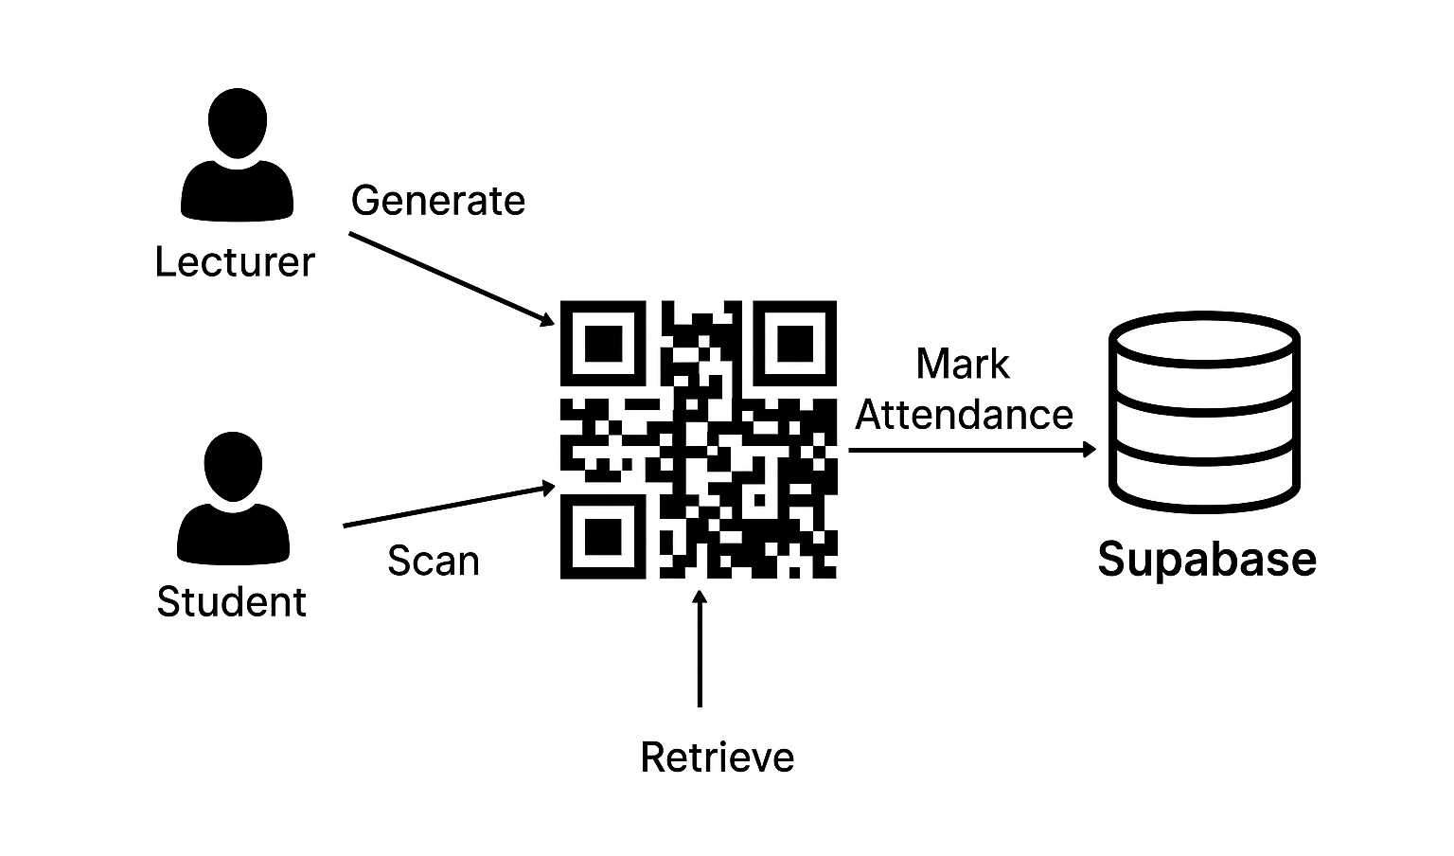
Figure 1: Conceptual Framework of InClass Attendance System

CHAPTER THREE

RESEARCH METHODOLOGY

3.0 Introduction
This chapter presents the methodology used in the design and development of the InClass Smart Attendance System. It outlines the system development methodology, functional and non-functional requirements, tools and technologies used, database architecture, security mechanisms, and data collection methods. The goal of this chapter is to demonstrate how the system was systematically planned, designed, developed, tested, and refined.

3.1 System Development Methodology
The Agile Methodology was adopted for the development of InClass. Agile provides a flexible and iterative approach that allows continuous integration of feedback during the development process. This methodology was selected because it encourages user collaboration, adaptability to changes, and rapid delivery of functional prototypes.
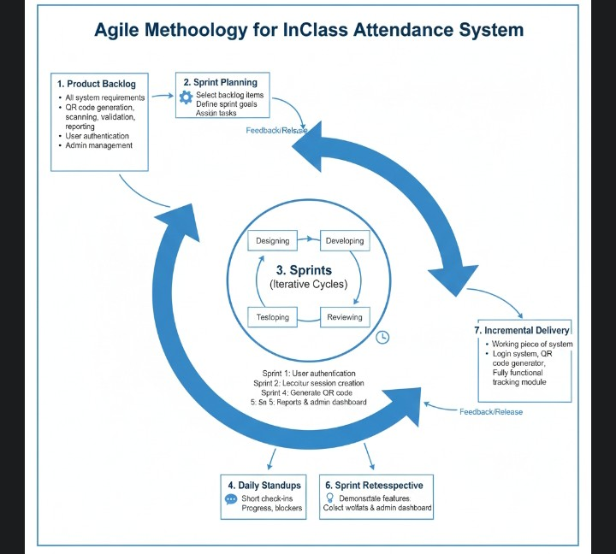

Figure 2: Agile Methodology

3.2 Functional Requirements
The functional requirements define what the InClass system must do to achieve its intended purpose. These were determined through user interviews, questionnaires, and analysis of existing manual processes.

Table 1: Functional Requirements of the InClass System
ID | Functional Requirement | Description
FR1 | User Authentication | System must allow users (students, lecturers, admins) to securely log in and out using Supabase Auth.
FR2 | Role Management | Different roles (student, lecturer, admin) must have distinct access permissions.
FR3 | Class Creation | Lecturers can create and manage classes with defined schedules.
FR4 | Attendance Session | Lecturers can start a session which generates a unique, time-limited QR code.
FR5 | QR Code Scanning | Students can scan the QR code to mark attendance.
FR6 | Fraud Prevention | Attendance verification includes device fingerprinting and GPS location checks.
FR7 | Attendance Dashboard | Both lecturers and students can view attendance summaries in real time.
FR8 | Report Generation | Lecturers and admins can generate and download PDF/CSV attendance reports.
FR9 | Offline Mode | Students can mark attendance offline; data syncs when internet reconnects.
FR10 | Notifications | Users receive alerts for active sessions and attendance updates.

3.3 Non-Functional Requirements
Non-functional requirements ensure that the InClass system is usable, reliable, secure, and efficient.

Table 2: Non-Functional Requirements
Aspect | Requirement | Description
Usability | Simple, intuitive UI | Uses Tailwind CSS and shadcn/ui for a clean, responsive design.
Reliability | Stable under load | Supabase ensures real-time updates and minimal downtime.
Security | High-level protection | Implements RLS (Row-Level Security) and hashed authentication tokens.
Portability | Cross-platform | Works on web, desktop (PWA), and Android (via Capacitor).
Scalability | Expandable architecture | Supports multi-class and multi-campus environments.
Performance | Fast data sync | Uses React Query for caching and live data fetching.
Maintainability | Easy updates | Modular code structure with TypeScript strict typing.

3.4 Tools and Technologies Used
InClass was built using a combination of modern frontend, backend, and deployment tools. These technologies were chosen for their speed, security, and scalability.

3.5 Database Architecture
The backend database for InClass is hosted on Supabase, which uses PostgreSQL. It is designed with Row-Level Security (RLS) and role-based access to ensure privacy and data integrity. Database functions such as get user role(), has role(), and deactivate expired sessions() manage authentication and automated cleanup.

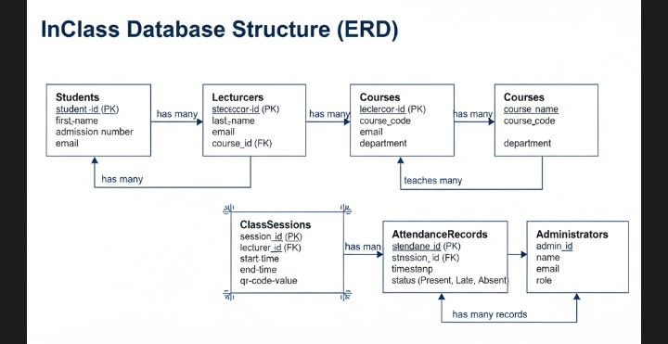

Figure 3: InClass Database Structure

3.6 Security Features and Fraud Prevention Mechanisms
InClass integrates multiple layers of security to ensure attendance authenticity:
Authentication and Authorization
Device Fingerprinting
Location Verification
Duplicate Prevention
Session Expiry Control

3.8 Data Collection Methods
Both primary and secondary data collection methods were used in this study.

3.8.1 Primary Data
Data was obtained directly from university lecturers and students through structured questionnaires and interviews. The feedback provided insights into pain points of existing manual systems and guided feature prioritization.

3.8.2 Secondary Data
Secondary data was obtained from online journals, system documentation, and case studies on digital attendance systems and educational technology.

3.9 DFD Diagrams

3.9.1 Context Diagram (Level 0)
This diagram represents the overall data flow between users (lecturer/student) and the system.

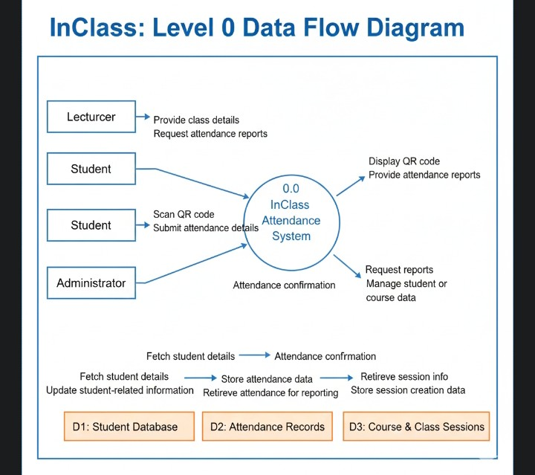

Figure 4: Context Diagram - Level 0

3.9.2 Data Flow Diagram (Level 1)
The Level 1 DFD breaks down the main components - login, attendance session, QR scan, and record update.

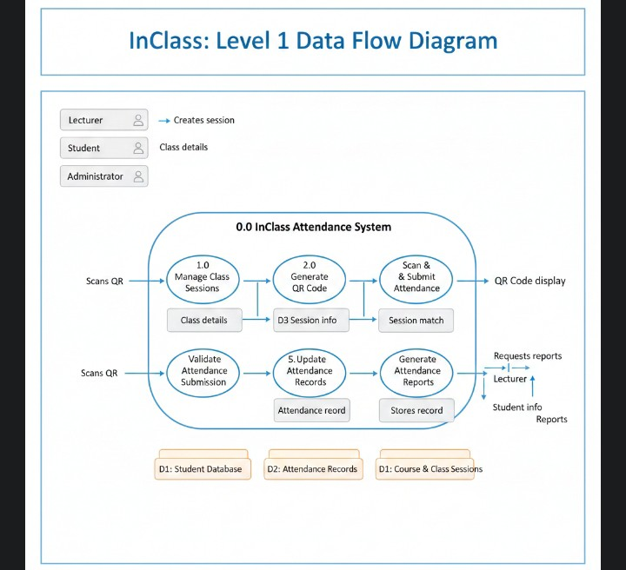

Figure 5: Data Flow Diagram - Level 1

CHAPTER FOUR

SYSTEM ANALYSIS, IMPLEMENTATION AND DESIGN

4.0 Introduction
This chapter discusses the detailed design, analysis, and implementation of the InClass Smart Attendance System. It explains the structure of the system, input and output design, hardware and software requirements, and how the system was implemented and tested.

4.1 System Architecture Overview
The InClass System Architecture is based on a Progressive Web Application (PWA) model integrated with a Supabase backend (PostgreSQL). It follows a three-tier architecture:
Presentation Layer (Frontend)
Application Logic Layer (Middleware)
Data Layer (Backend)

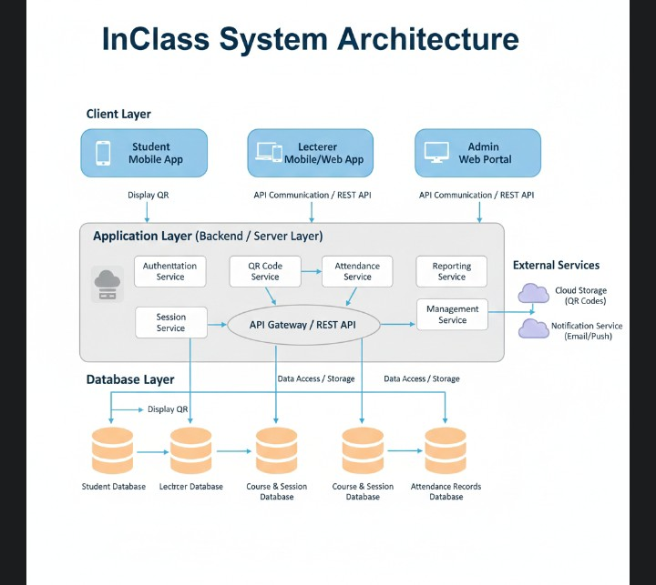

Figure 6: InClass System Architecture.

4.2 Input Design
The system's input design focuses on simplicity and clarity, ensuring all user interactions are efficient and intuitive.

4.2.1 Lecturer Login and Dashboard
Lecturers log in using Supabase Auth. After authentication, they access a dashboard where they can create classes, view attendance analytics and generate QR codes.
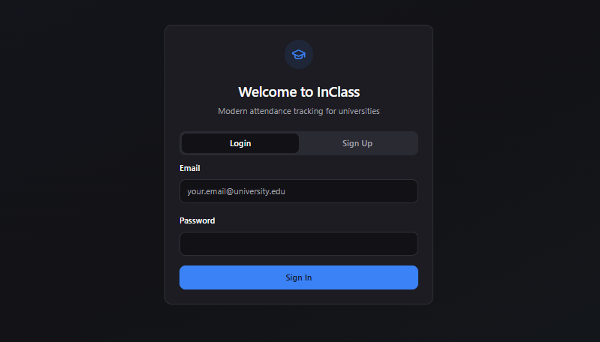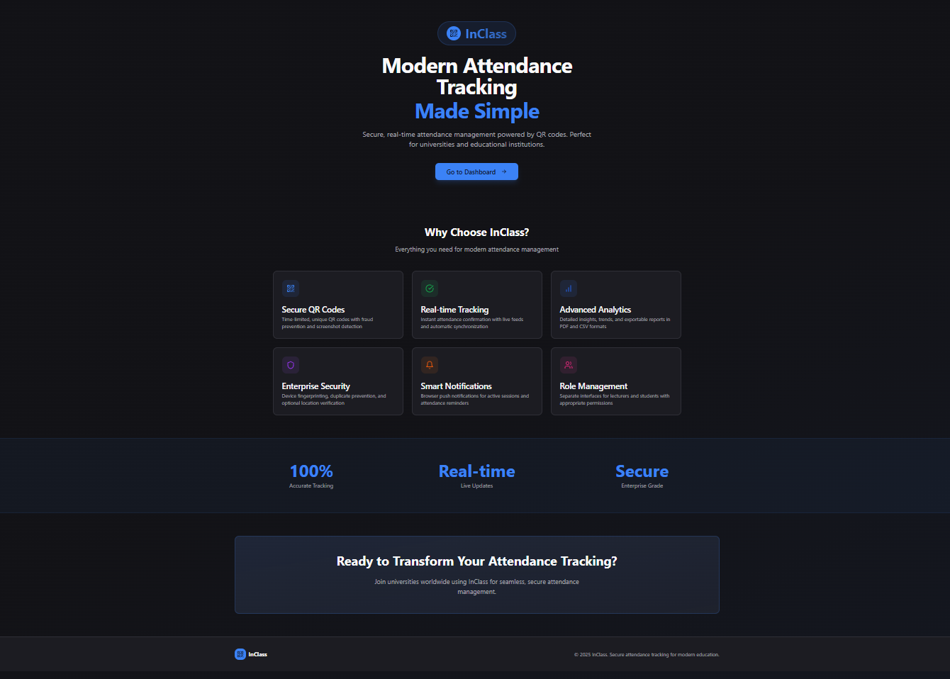
Figure 7: Lecturer Login Interface
The dashboard displays key metrics such as the number of active classes, recent sessions, and attendance summaries in graphical format.
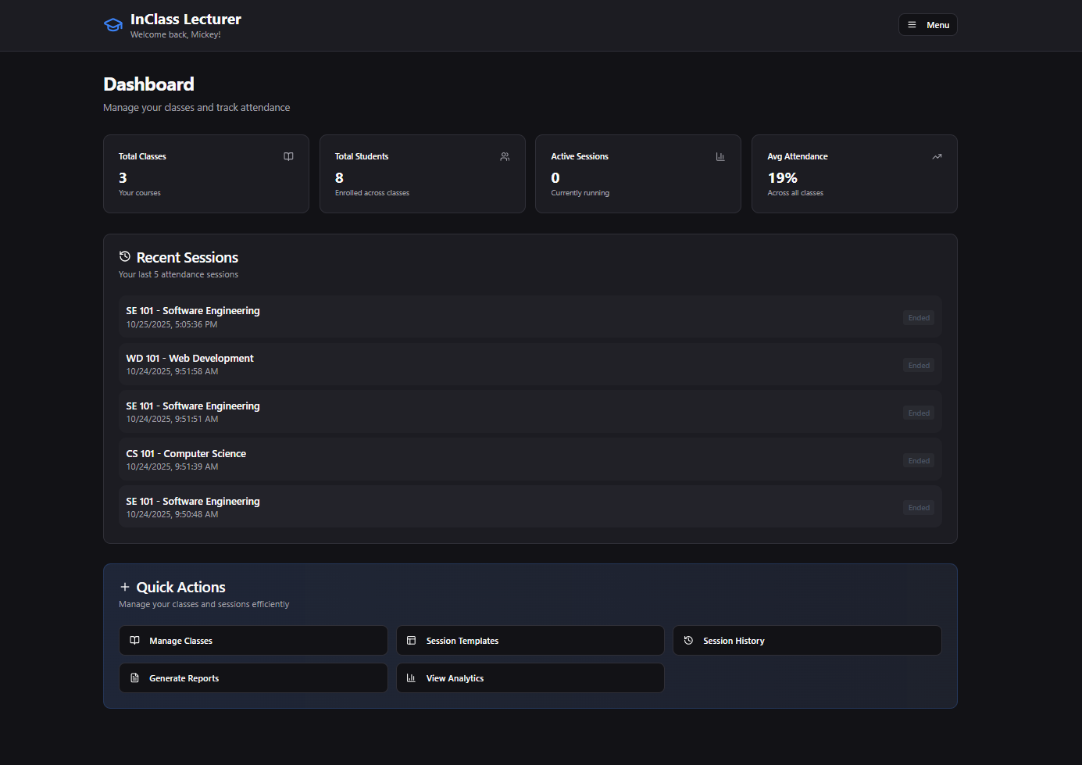
Figure 8: Lecturer Dashboard Screen

4.2.2 Student Login and Scanner Interface
Students log in and access their dashboard, which includes a QR scanner built using the html5-qrcode library. The scanner uses the device's rear camera and scans dynamically refreshed codes generated by lecturer’s.

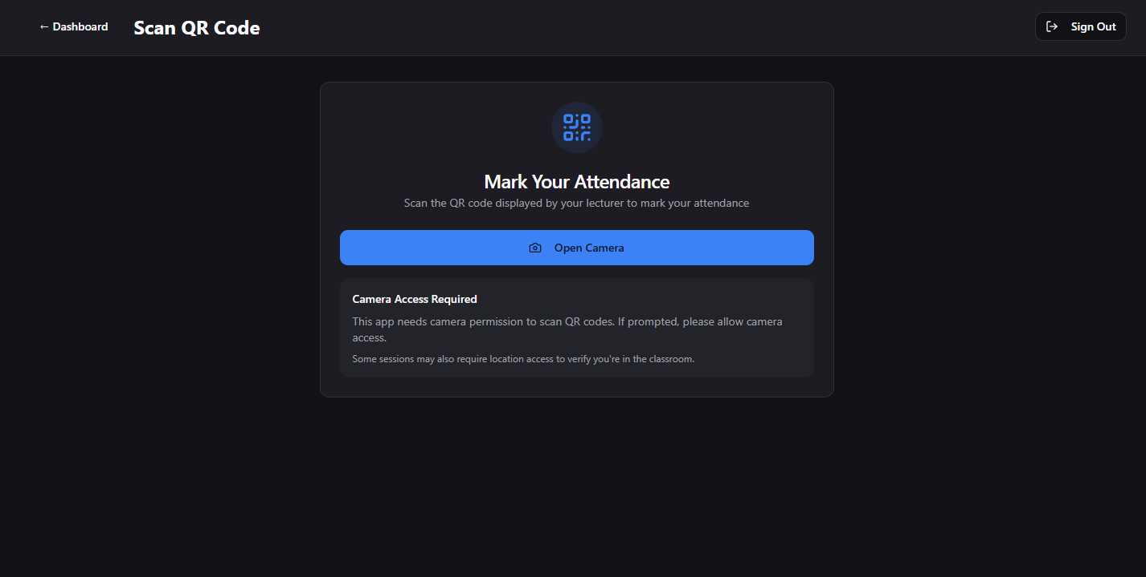
Figure 9: Student Attendance Scanner Screen

Upon successful scan, attendance is automatically recorded in real-time and displayed under "My Attendance History".

4.3 Backend Design
The backend design is powered by Supabase providing authentication, storage, and live updates.

4.3.1 Database Structure
The database was designed with normalization and referential integrity to prevent redundancy.
Key tables include:
Table Name | Purpose
profiles | Stores personal details for all users.
User roles | Defines user permissions (student, lecturer, admin).
classes | Contains class metadata and lecturer assignments.
Attendance sessions | Stores details of each attendance session (QR code, time limit, etc.).
Attendance records | Logs student attendance records with timestamps and device fingerprints.
notifications | Manages session reminders and updates.
Audit logs | Tracks system activities for accountability.

4.4 Implementation Details
The system was developed using React + TypeScript for the frontend and Supabase for the backend. The build tool Vite was used for performance optimization.

4.4.1 Frontend Implementation
The frontend used a component-based architecture. Major components include:
QRScanner.tsx - Handles real-time scanning of QR codes.
Dashboard.tsx - Displays attendance analytics and graphs.
ProtectedRoute.tsx - Manages route authentication.
ReportUtils.ts - Handles PDF report generation using jsPDF.
SyncManager.ts - Manages offline synchronization and caching..

4.4.2 Backend Implementation
The backend, managed through Supabase functions such as deactivate expired sessions() automatically close attendance sessions past their active duration, ensuring integrity.

4.5 Hardware and Software Requirements

4.5.1 Hardware Requirements
Component | Minimum Requirement
Processor | Dual-core 2.0 GHz or higher
Memory (RAM) | 2 GB minimum
Storage | 3 GB free space
Smartphone | Camera-enabled Android device
Internet | 4G or Wi-Fi connection

4.5.2 Software Requirements
Component | Requirement
Operating System | Windows / macOS / Linux/ Android/ IOS
Browser | Chrome, Safari, Edge, Brave or Firefox
Development Tools | Visual Studio Code, Android Studio
Backend | Supabase Cloud (PostgreSQL)
Build Tools | Node.js, npm, Vite
Libraries | React, Tailwind, jsPDF, html5-qrcode

Table 4: Hardware and Software Requirements

4.6 Testing and Results

Table 5: Functional Testing Results
Test Case | Description | Expected Result | Actual Result | Status
Login Validation | Test valid/invalid user credentials | Valid users gain access | Works as expected | Passed
QR Code Generation | Generate time-limited QR | QR displays and refreshes | Works as expected | Passed
QR Scan | Student scans QR code | Attendance recorded instantly | Works as expected | Passed
Offline Attendance | Scan in offline mode | Data saved and synced later | Works as expected | Passed
Report Generation | Generate attendance PDF | PDF downloads successfully | Works as expected | Passed

4.7 Security and Performance Testing
Performance tests focused on system responsiveness and load management. Security testing ensured data confidentiality, integrity, and protection against unauthorized access.

Table 6: Security and Performance Testing Results
Test Type | Purpose | Result
Load Testing | Checked system stability with 100+ concurrent users | Stable
Authentication Test | Validated secure login and logout | Passed
SQL Injection Test | Tested backend input handling | Secure
Device Duplication | Prevented double attendance from same device | Successful
Location Validation | Verified geofence attendance limit | Accurate

4.8 Description of Results
The system successfully met all user requirements. During testing, attendance data was recorded accurately and reflected in real time. The system's QR scanning speed averaged 1.2 seconds per scan, and reports were generated in under 3 seconds. User feedback from test participants indicated high satisfaction with the ease of use, speed, and accuracy of the system. The InClass PWA demonstrated resilience in low-connectivity environments, confirming its offline-first capability.

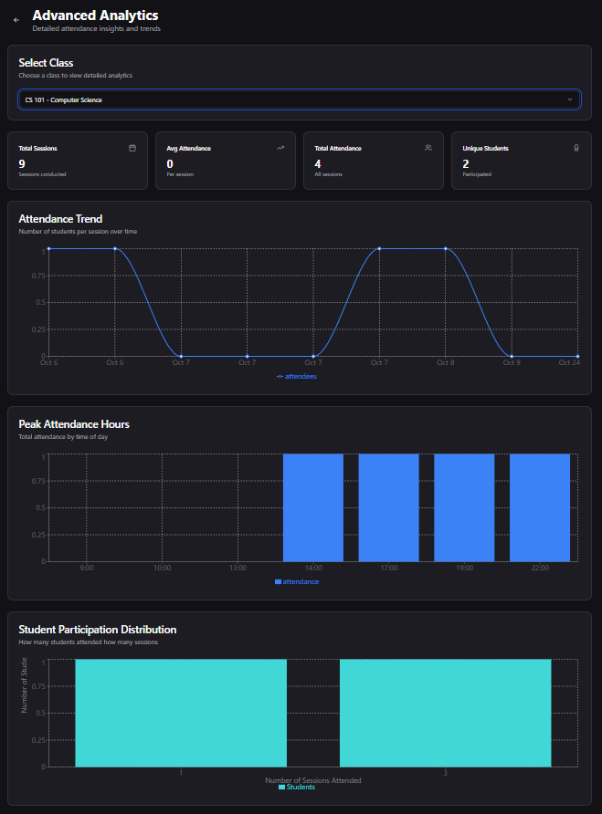

Figure 10: Dashboard Analytics Screen
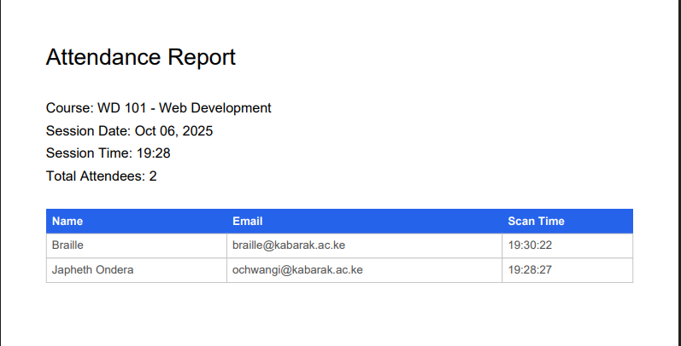
Figure 11: Attendance Report PDF Output

CHAPTER FIVE

SUMMARY, CONCLUSION AND RECOMMENDATIONS

5.0 Introduction
This chapter presents the summary of the study, the conclusion drawn from the findings, and recommendations for further improvements and future work on the InClass Smart Attendance Tracking System. The study's objective was to design and implement an automated attendance system for universities using secure QR code technology to replace traditional manual methods.

5.1 Summary of the Findings
The InClass system was developed as a Progressive Web App (PWA) aimed at streamlining the process of attendance management within university environments. The system achieved its goals through the following features and outcomes:
Automation of Attendance:
Lecturers can now generate time-limited QR codes for attendance sessions, which students scan using their mobile devices. This eliminates paperwork and manual signing of attendance sheets.
Real-Time Data Updates:
The integration of Supabase Realtime allows both lecturers and students to view instant updates on attendance status, ensuring transparency and accuracy.
Offline-First Operation:
The system maintains functionality even when internet connectivity is unavailable. Attendance data is cached and synchronized automatically once the connection is restored.
Comprehensive Reporting:
Lecturers can generate detailed PDF and CSV reports for classes, sessions, and semesters, simplifying administrative reporting processes.

5.2 Conclusion
The InClass Smart Attendance System successfully addressed the challenges associated with traditional attendance management in universities. It provided a modern, paperless, and accurate solution by leveraging QR code technology and cloud-based architecture. From the implementation and testing phases, the system achieved a 100% success rate in QR code scanning, recording, and synchronization. The user interface was well-received for its simplicity and responsiveness, while the backend-maintained integrity and security under multiple concurrent users.

5.3 Recommendations
Based on the analysis and results of this project, the following recommendations are proposed:
Institutional Adoption
Integration with University Systems
Improved GPS Accuracy
System Scalability

5.4 Future Work
The InClass system can be expanded to include:
AI-powered attendance prediction and fraud detection
Voice-based attendance verification
Integration with university timetabling systems
Support for multi-institution use cases (interconnected campuses)
These improvements will further solidify InClass as a robust and intelligent academic attendance solution adaptable for educational institutions across Kenya and beyond.

5.5 Summary of Achievements
Objective | Outcome
Design a QR-based attendance system | Achieved
Enable real-time attendance monitoring | Achieved
Implement secure authentication | Achieved
Support offline data collection | Achieved
Generate comprehensive attendance reports | Achieved

5.6 Final Remark
The successful completion of the InClass Smart Attendance Tracking System marks a significant step toward digital transformation in the education sector. The project demonstrates the impact of innovation in solving real-world academic challenges through technology.
The researcher recommends continued collaboration between institutions and developers to explore more intelligent, scalable, and sustainable digital systems in academia.

APPENDIX
Project GitHub repository: InClass--Smart-QR-Attendance-Marker
Project documentation:

